# Snapshots

## First get the free Smart agent App for JIRA from Github Marketplace.

## Register a Github copilot App for Discover and connect to your service API.

## Follow the setup in git help and Start the Volt Service.

* <https://github.com/mayur11235/volt_service/blob/main/README.md>
* Also register callback and authorization endpoints in Github app setting.

## JIRA project setup for Demo with 3 TO DO tasks

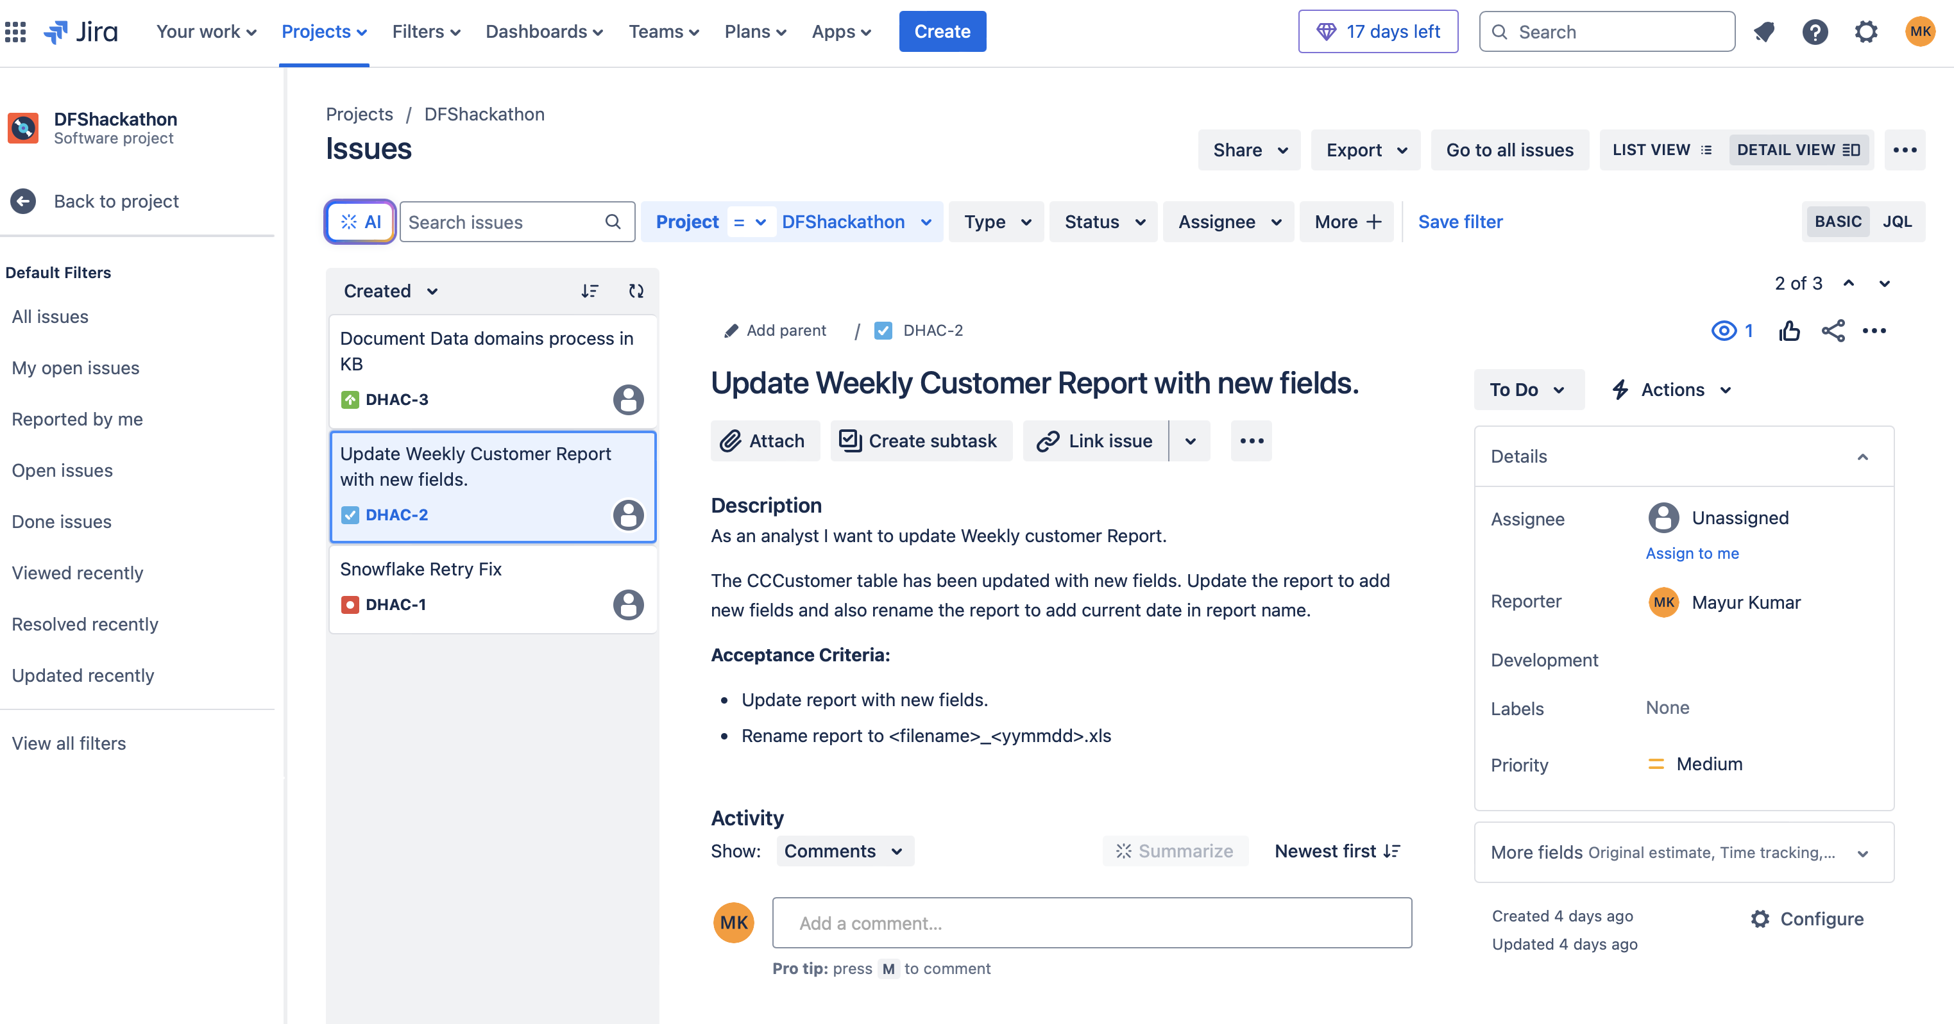

## After agents are installed in Visual Studio and authorized, we start the Demo. First Let’s talk to Volt.

## Next ask Rovo to get ALL TODO tasks from JIRA.

## Ask Rovo to summarize DHAC-2

## Ask Volt to get list of fields in Credit Card Customer Table.

## Ask Copilot to analyze Workspace for missing fields.

## Ask copilot to analyze code and add missing fields to report.

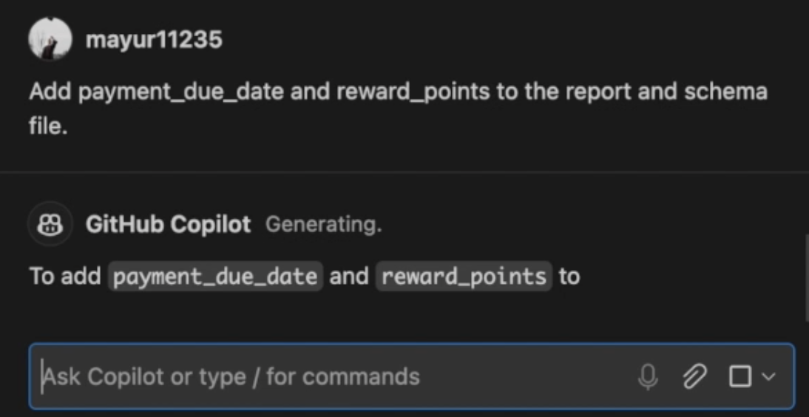

## Copilot suggest code changes and those are applied.

## Ask volt to get links related to Rewards Program from Sharepoint

